**CSS Blöcke**

<!DOCTYPE html>

<html>

<head>

<style>

div.container {

width: 100%;

margin: 0px;

border: 1px solid gray;

line-height: 150%;}

div.header, div.footer {

padding: 0.5em;

color: white;

background-color: gray;

clear: left;}

h1.header {

padding: 0;

margin: 0;}

div.left {

float: left;

width: 160px;

margin: 0;

padding: 1em;}

div.content {

margin-left: 190px;

border-left: 1px solid gray;

padding: 1em;}

</style>

</head>

<body>

<div class="container">

<div class="header"><h1 class="header">W3Schools.com</h1></div>

<div class="left"><p>"Never increase, beyond what is necessary, the number of entities required to explain anything." William of Ockham (1285-1349)</p></div>

<div class="content">

<h2>Free Web Building Tutorials</h2>

<p>At W3Schools you will find all the Web-building tutorials you need.</p>

<p>W3Schools.com - The largest Web Developers' Site on the internet!</p>

</div>

<div class="footer">© Copyright by Refsnes Data.</div>

</div></body></html>

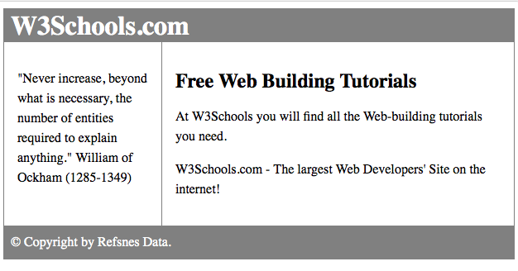

**Navigation1**

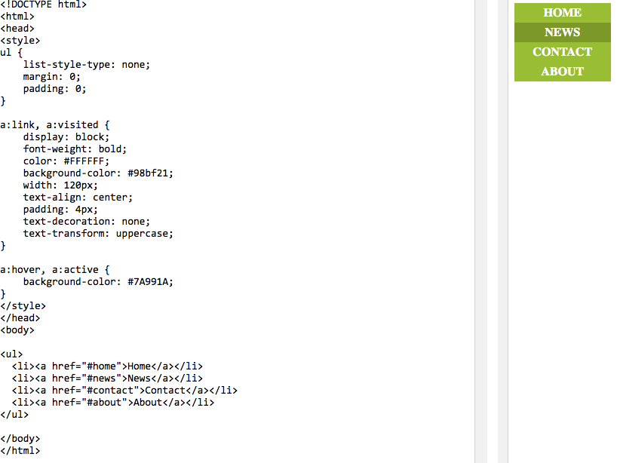

**Navigation2**

